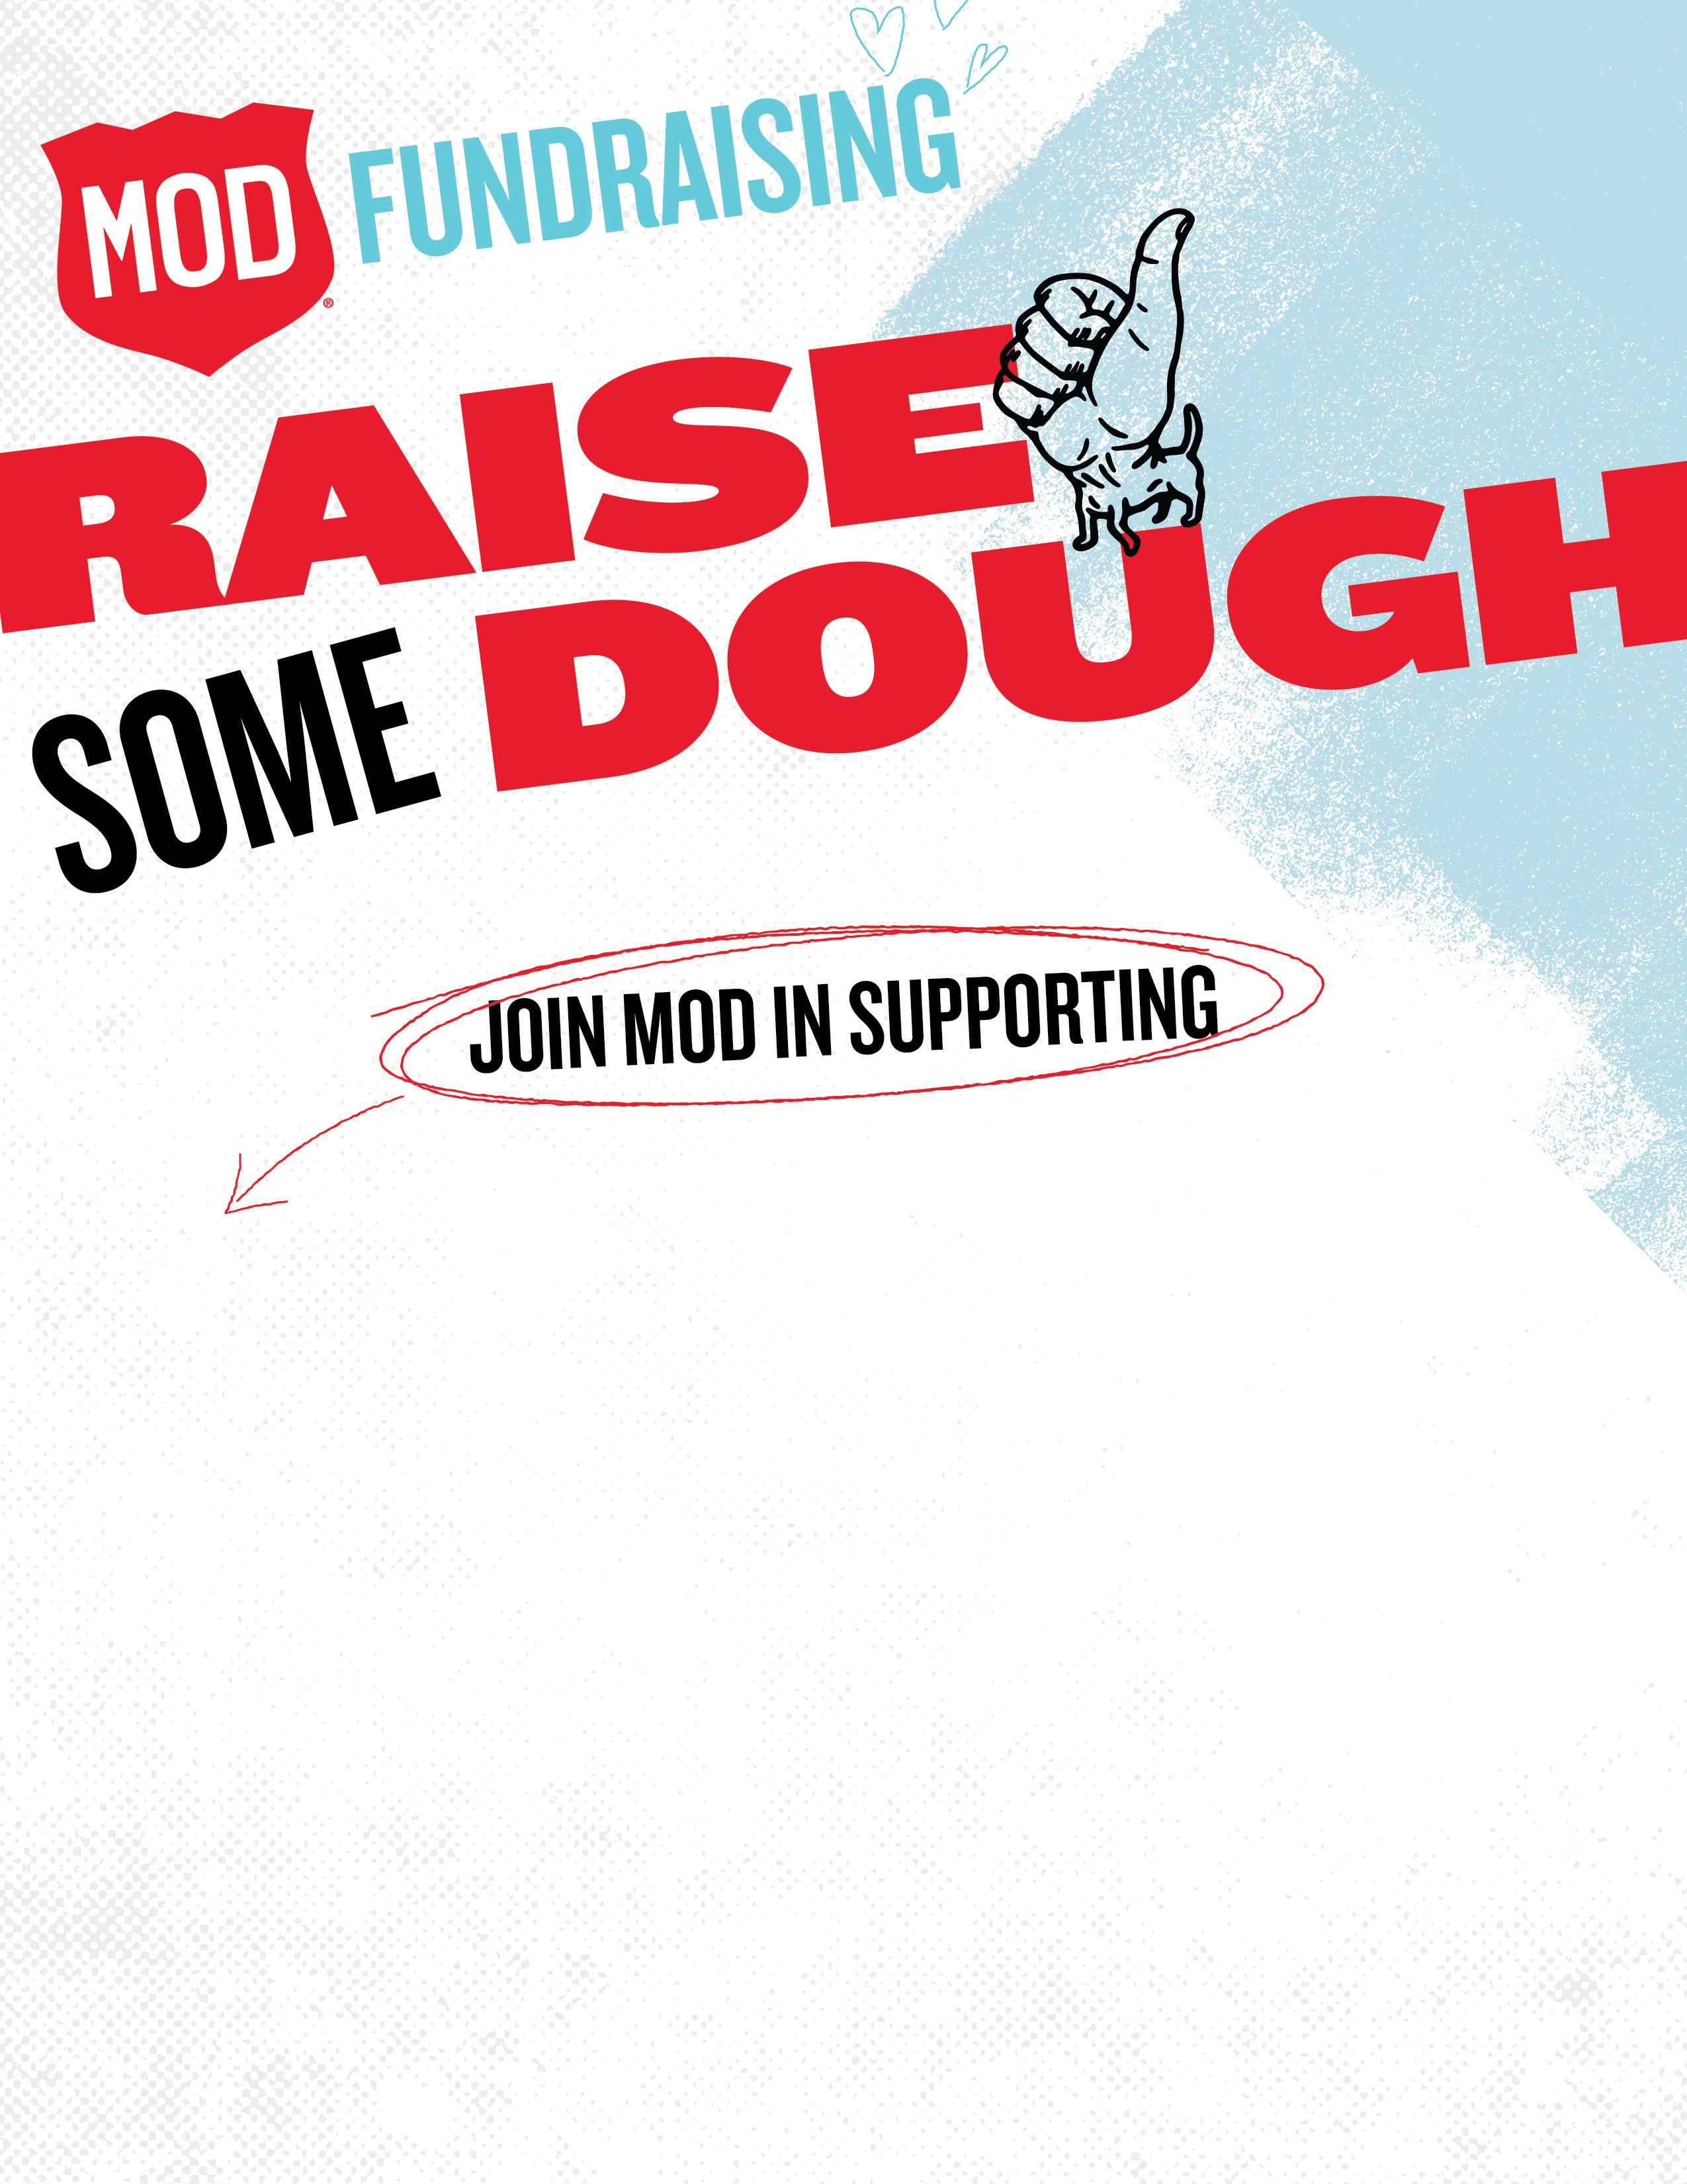

ORGANIZATION NAME:

BRUNSWICK VOLUNTEER AMBULANCE AND

RESCUE COMPANY INC

FUNDRAISER DATE:

OCTOBER 22, 2023

Bring in this flyer, or order online through the MOD app or website using the

provided coupon and MOD will donate 20% of your bill to support this great work!

ADDRESS:

5265

BUCKEYSTOWN PIKE

FREDERICK, MD 21704

FUNDRAISER CODE:

MODGIVES20

Offer valid only on the date(s) and at the MOD location identified on this flyer. Offer valid for dine-in, take out, or delivery when ordered through

the MOD app or website only. For online or in-app orders, please use the code MODGIVES20. For delivery, customer must live within delivery

boundary. Only non-profit organizations and non-profit schools are eligible to participate in the MOD fundraising program. MOD will donate 20%

of food and beverage sales to the organization. Tax, gift cards and retail sales are excluded

from the donation. Offer void if the

flyer is distributed in

or near the restaurant. For more information about fundraising, visit

https://modpizza.com/fundraisers

[/](https://modpizza.com/fundraisers/)